CTM-I Test Plan

Menu Tab: Security

Screen: User Maintenance - Add

Version 0.1

Menu Tab: Security

Use Case Name | User Maintenance; Add
User Roles | Firm User(CTMI_Firm_Options_Root, CTMI_Firm_Options_Admin, CTMI_Firm_Futuress_Root, CTMI_Firm_Futures_Admin), Market Ops(CTMI_Help_Desk), App Support(CTMI_Root)
Pre-conditions /Assumptions | User has successfully logged into the CTM-I application.
Post Conditions | None
Screenshot | 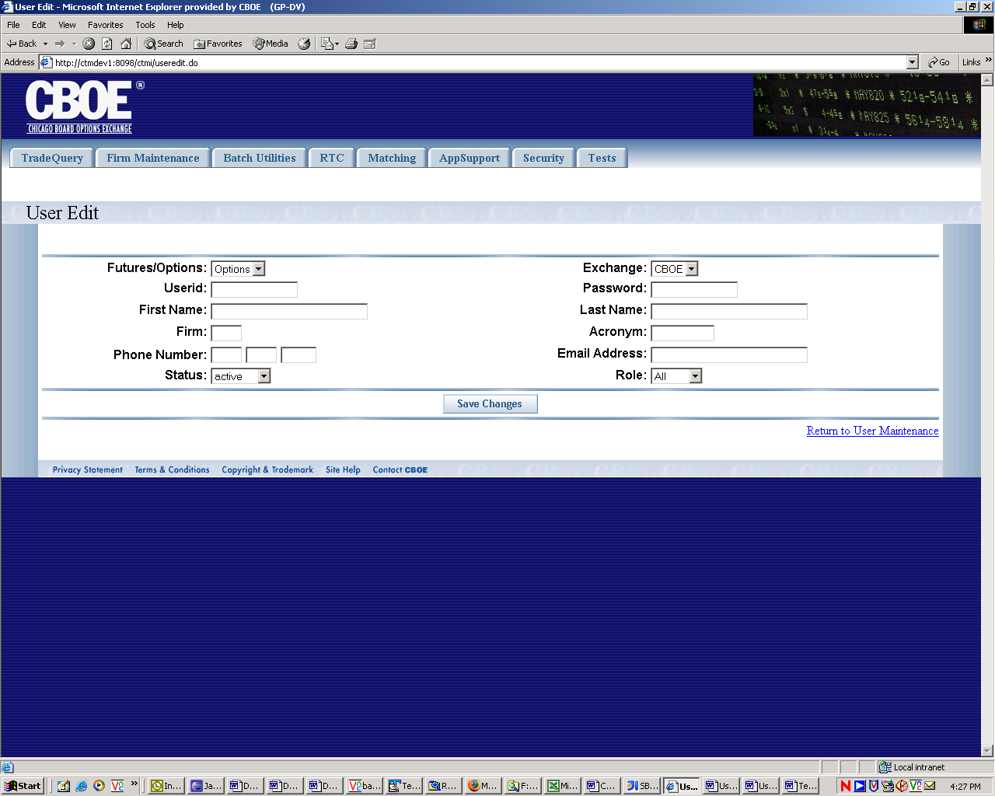
Test Scenario A | User Role : CTMI_Firm_Options_Root, User Id: xxx Password: xxx
 | Action | Expected Out Come | Comments/Results
Test Case 1  Edit Function | User clicks on ‘Edit’ link next to each row displayed. | User Edit Screen appears displaying information on the selected user. The following user data are displayed and are editable.  - Futures/Options (Drop Down)  - Exchange (Drop Down)  - User Id– Editable Text  - Password (Text)  - First Name (Text)  - Last name (Text)  - Firm (Text)  - Acronym (Text)  - Phone Number (Text)  - Email Address (Text)  - Status (Drop Down)  - Role (Drop Down)
 | User Enters any information he/she wants to change and clicks on ‘Save Changes’ button. | User Data is saved and User Edit Screen continues to be displayed. | Basic Flow
 |  | Save Failed – Error Message on Screen stating the reason for failure. | Alternate Flow – Error Condition. Failure From server Side.
User Id – Max 8 Char | User enters user Id exceeding 8 chars | Error Message – User Id can not exceed 8 char. | Client Side Data Validation
Non-numeric Firm | User enters non-numeric firm on the firm Text Box | Error Message – Firm Can not be non-numeric | Client Side Data Validation
Firm more than 3 digits | User enters more than 3 digits on the firm Text Box | Error Message – Firm Can not be more than 3 digits | Client Side Data Validation
Password not exactly 8 char long. | User enters less than 8 or more than 8 characters for Password Field | Error Message – Password cannot be more than 8 chars or less than 8 chars. | Client Side Data Validation
Acronym Validation ??
Phone Number Validation | User Enters non numeric character in phone number fields or enters less than ore more than 3/3/4 digits on the three phone fields. | Error Message- Invalid Phone number
Email Address Validation | User enters email that does not conform standard email address abc@abc.com | Error Message – Invalid Email Address
Required fields | User enters - Password, Firm, Acronym fields are blank | Error Message - Password, Firm, Acronym fields can not be blank
Exchange Drop Down Population | User Selects ‘Options’ on the Option/Future drop down | Exchange drop down should only display ‘CBOE’
 | User Selects ‘Futures’ on the Option/Future drop down | Exchange drop down should only display ‘CBOE’, ‘CBOT’, ‘CME’
Test Scenario B | Repeat above test cases with login with diff user roles namely Ops (CTMI_Firm_Options_Admin)  User Id: xxx Password: xxx
 | All Test Cases Same as Test Scenario A
Test Scenario C | Repeat above test cases with login with diff user roles namely Ops (CTMI_Firm_Futures_Root)  User Id: xxx Password: xxx
 | All Test Cases Same as Test Scenario A
Test Scenario D | Repeat above test cases with login with diff user roles namely Ops (CTMI_Firm_Futures_Admin)  User Id: xxx Password: xxx
 | All Test Cases Same as Test Scenario A
Test Scenario E | Repeat above test cases with login with diff user roles namely  AppSupport(CTMI_Root) User Id: xxx Password: xxx
 | Rest Same as Test Scenario A
Test Scenario F | Repeat above test cases with login with diff user roles namely AppSupport (CTMI_Systems)  User Id: xxx Password: xxx
 | Same as Test Scenario C
Test Scenario G | Repeat above test cases with login with diff user roles namely AppSupport (CTMI_Help_Desk)  User Id: xxx Password: xxx
 | Same as Test Scenario C

